Created 2 buckets, 1 for storing data, 1 for backup
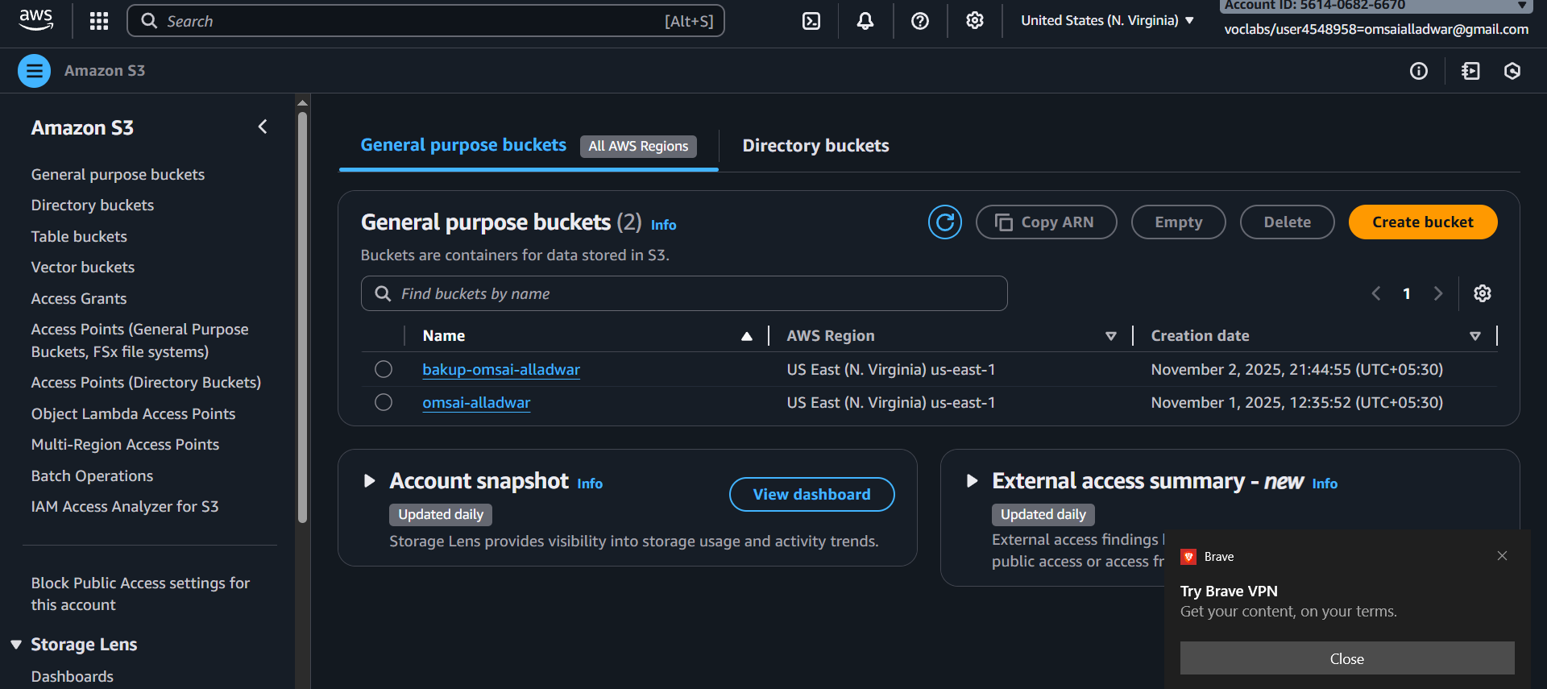
Added code to lambda function to copy object, from first bucket to backup

import json
import boto3

s3 = boto3.client('s3')

def lambda_handler(event, context):
try:
source_bucket = event['Records'][0]['s3']['bucket']['name']
key = event['Records'][0]['s3']['object']['key']
destination_bucket = "your-backup-bucket-name"

s3.copy_object(
Bucket=destination_bucket,
Key=key,
CopySource={"Bucket": source_bucket, "Key": key}
)

return {
'statusCode': 200,
'body': json.dumps("File copied")
}

except Exception as e:
print(e)
raise e

